# 

附件：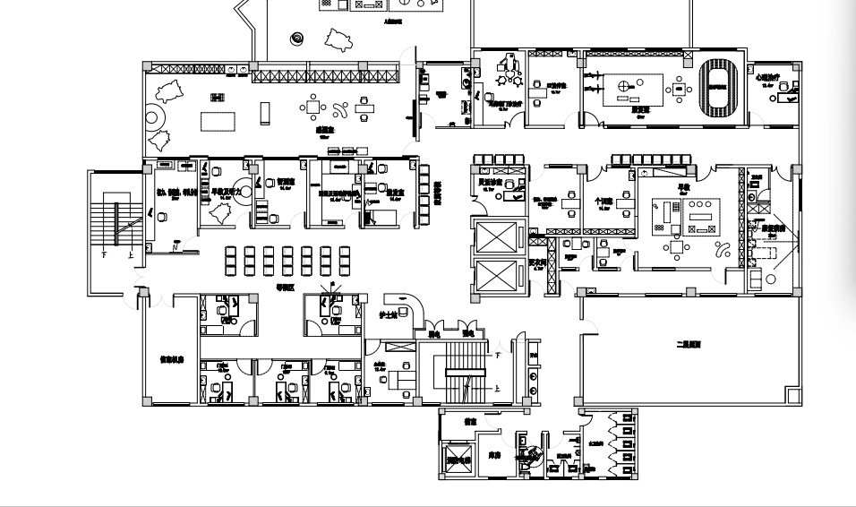

|  |  |  |  |  |  |  |  |  |
| --- | --- | --- | --- | --- | --- | --- | --- | --- |
| 开州区妇幼保健院儿童保健科改造建设工程项目 中央空调新增、移机采购询价清单 | | | | | | | | |
| 序号 | 名称 | 品牌 | 型号 | 单位 | 数量 | 单价 | 总价 | 备注 |
| 1 | 移机风机盘管 |  |  | 台 | 5 |  |  |  |
| 2 | 风机盘管 |  | EKCW1200YC | 台 | 3 |  |  | 新增 |
| 3 | 风机盘管 |  | EKCW600YC | 台 | 2 |  |  | 新增 |
| 4 | 控制面板 |  |  | 块 | 5 |  |  |  |
| 5 | 镀锌钢管 |  | DN40 | 米 | 30 |  |  |  |
| 6 | 镀锌钢管 |  | DN20 | 米 | 60 |  |  |  |
| 7 | 焊弯 |  | 40# | 个 | 6 |  |  |  |
| 8 | 焊弯 |  | 20# | 个 | 10 |  |  |  |
| 9 | 保温棉 |  | DN40 | 米 | 30 |  |  |  |
| 10 | 保温棉 |  | DN20 | 米 | 60 |  |  |  |
| 11 | 胶水 |  | 保温棉 | 桶 | 1 |  |  |  |
| 12 | Y型过滤器 |  | DN20 | 个 | 10 |  |  |  |
| 13 | 铜球阀 |  | DN20 | 个 | 20 |  |  |  |
| 14 | 不锈钢软接 |  | DN20 | 根 | 20 |  |  |  |
| 15 | 二通阀 |  | DN20 | 个 | 10 |  |  |  |
| 16 | 回风箱 |  | 保温板自制 | 个 | 5 |  |  |  |
| 17 | 风道 |  | 保温板自制 | 个 | 8 |  |  |  |
| 18 | 帆布软接 |  |  | ㎡ | 18 |  |  |  |
| 19 | 出风口 |  | 1000*150 | 个 | 30 |  |  |  |
| 20 | 回风口 |  | 1000*200 | 个 | 30 |  |  |  |
| 21 | 排水管 |  | DN40 | 米 | 30 |  |  |  |
| 22 | 排水管 |  | DN25 | 米 | 60 |  |  |  |
| 23 | 控制线 |  | 0.75*6 | 米 | 100 |  |  |  |
| 24 | 电源线 |  | 4m2 | 米 | 100 |  |  |
| 25 | 线管 |  | 16# | 根 | 20 |  |  |  |
| 26 | 吊杆 |  |  | 根 | 40 |  |  |  |
| 27 | 焊工工时 |  |  |  |  |  |  |  |
|  | 合计： |  |  |  |  |  |  |  |
|  |  |  |  |  |  | | | |
|  |  |  |  |  |  | | |  |
|  |  |  |  |  |  |  |  |  |
|  |  |  |  |  |  |  |  |  |
|  |  |  |  |  |  |  |  |  |
|  |  |  |  |  |  |  |  |  |
|  |  |  |  |  |  |  |  |  |
|  |  |  |  |  |  |  |  |  |
|  |  |  |  |  |  |  |  |  |
|  |  |  |  |  |  |  |  |  |
|  |  |  |  |  |  |  |  |  |
|  |  |  |  |  |  |  |  |  |
|  |  |  |  |  |  |  |  |  |
|  |  |  |  |  |  |  |  |  |
|  |  |  |  |  |  |  |  |  |
|  |  |  |  |  |  |  |  |  |
|  |  |  |  |  |  |  |  |  |
|  |  |  |  |  |  |  |  |  |
|  |  |  |  |  |  |  |  |  |
|  |  |  |  |  |  |  |  |  |
|  |  |  |  |  |  |  |  |  |
|  |  |  |  |  |  |  |  |  |
|  |  |  |  |  |  |  |  |  |
|  |  |  |  |  |  |  |  |  |
|  |  |  |  |  |  |  |  |  |
|  |  |  |  |  |  |  |  |  |
|  |  |  |  |  |  |  |  |  |
|  |  |  |  |  |  |  |  |  |
|  |  |  |  |  |  |  |  |  |
|  |  |  |  |  |  |  |  |  |
|  |  |  |  |  |  |  |  |  |
|  |  |  |  |  |  |  |  |  |
|  |  |  |  |  |  |  |  |  |
|  |  |  |  |  |  |  |  |  |
|  |  |  |  |  |  |  |  |  |
|  |  |  |  |  |  |  |  |  |
|  |  |  |  |  |  |  |  |  |
|  |  |  |  |  |  |  |  |  |
|  |  |  |  |  |  |  |  |  |
|  |  |  |  |  |  |  |  |  |
|  |  |  |  |  |  |  |  |  |
|  |  |  |  |  |  |  |  |  |
|  |  |  |  |  |  |  |  |  |
|  |  |  |  |  |  |  |  |  |
|  |  |  |  |  |  |  |  |  |
|  |  |  |  |  |  |  |  |  |
|  |  |  |  |  |  |  |  |  |

